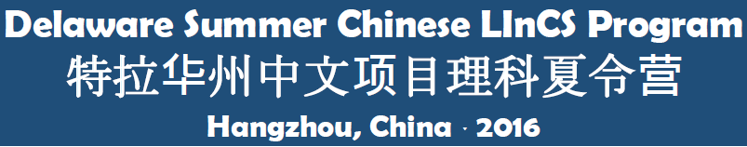
Delaware Summer Chinese LInCS Student Learning Products
Purpose: To demonstrate the impact of this immersion experience on your understanding of the relationship of studying Chinese language and culture and using these skills in the STEM-context of green energy development.
Product: 3-5-minute, multi-media table-top presentation with a partner on one of the following topics:
- American vs. Chinese Perspectives on a Green Energy Solution
- Chinese Language Skills as an Advantage for College and Career Options
- American and Chinese Cultural Differences and Ways to Facilitate Cooperation and Collaboration
Audience: State officials and Delaware business owners in the field of green energy
Product Due Date: Friday, August 26
Tentative Presentation Venue and Date: Official Recognition Reception to honor Student Participants in Dover, Week of September 26-29, 2016, 5-7 pm
Pre-Departure
- Determine topic of interest
- Discuss choice with teacher-chaperone
- Conduct preliminary research to answer focus questions related to your chosen topic
- Document U.S. perspectives on your chosen topic
- Secure technology you will need to collect visual documentation
Onsite
- Document Chinese perspectives on your chosen topic
  - Notes from presentations
  - Interviews with professors, ambassadors, and business community members
  - Samples from company visits
  - Photos
  - Videos
- Prepare outline of presentation through weekly check-ins with teacher-chaperones
- Complete a solid draft of presentation
Post -Travel
- Participate in a Follow-Up Meeting in August (Tentatively Saturday, August 20)
- Submit final project by Friday, August 26
- Present project at Recognition Reception in September

